Before | During
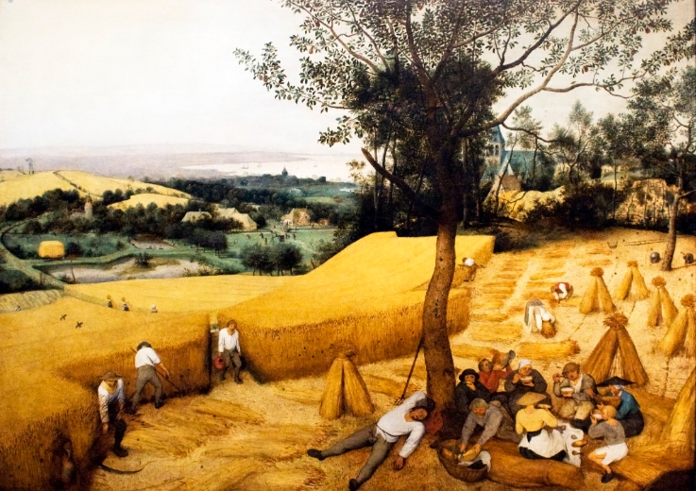 | 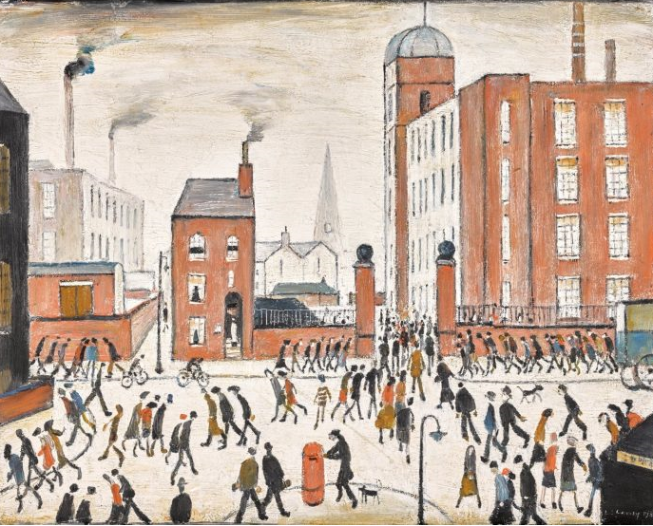
Similarities and Differences

Word Bank:
Agricultural Industrial Factory Population Urban Rural Pollution

