Maths | English | Reading | Topic/Science
Weekly Focus:  Year 3:  Year 4: Division  (please watch the videos and complete the worksheets) | Weekly Focus: Journey – by Aaron Becker  Link to the story:  https://www.youtube.com/watch?v=kWqhNpjvcSs​ | Text/s:  The lost diary of Sami Star | Topic Unit: The Stone Age  Science Unit: States of Matter
Monday:  Year 3: To investigate different combinations.  https://vimeo.com/496812718  https://assets.whiterosemaths.com/fixed/res/2019/11/Y3-Spring-Block-1-WO9-How-many-ways_-2019.pdf  Year 4 : To divide 3 digits by 1 digit  https://vimeo.com/497992648  https://assets.whiterosemaths.com/fixed/res/2020/06/Y4-Spring-Block-1-WO10-Divide-3-digits-by-1-digit-2019.pdf | Monday:  How is the bird moving to get away?  E.g. zig-zagged  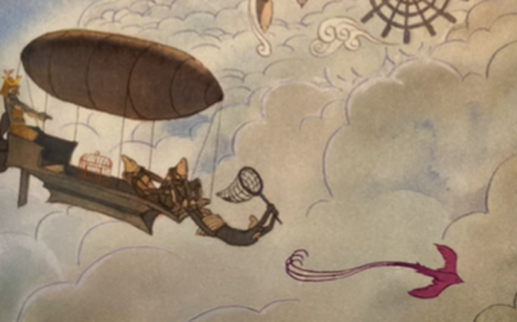  Think of synonyms for feeling trapped.  E.g. captured  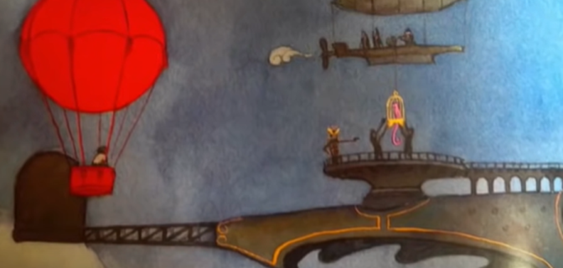  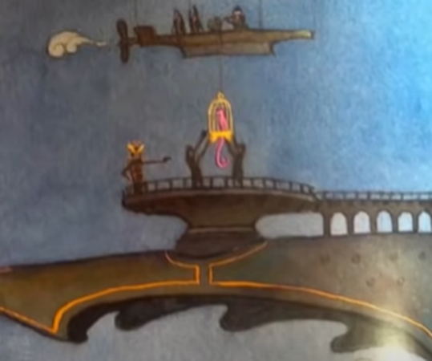  How would the girl approach the zeppelin? E.g. quietly floating. | Monday:  Guided Reading:  The lost diary of Sami Star | Monday:  Forest School:  Make a natural birdfeeder and hang it up in your garden.
Tuesday:  Year 3: Have a go at the end of unit assessment.  Year 4: Correspondence problems  https://vimeo.com/498265698  https://assets.whiterosemaths.com/fixed/res/2019/11/Y4-Spring-Block-1-WO11-Correspondence-problems-2019.pdf | Tuesday:  Plan your own version of the story using the planning document on the website. | Tuesday:  Guided Reading:  The lost diary of Sami Star | Tuesday:  PE: Joe Wicks  Choose a video and complete the workout  https://www.youtube.com/playlist?list=PLyCLoPd4VxBuS4UeyHMccVAjpWaNbGomt
Wednesday:  Year 3: To count money in pence  https://vimeo.com/497343674  https://assets.whiterosemaths.com/fixed/res/2019/09/Y2-Autumn-Block-3-WO1-Count-money-pence-2019.pdf  Year 4: Complete the end of unit assessment | Wednesday:  Draft your own version of the story. | Wednesday:  Reading for pleasure: read your book for 20 minutes | Wednesday:  Spend afternoon doing something you really enjoy doing – let us know what you choose!
Thursday:  Year 3: To count money in pounds  https://vimeo.com/497344241  https://assets.whiterosemaths.com/fixed/res/2019/09/Y2-Autumn-Block-3-WO2-Count-money-pounds-2019.pdf  Year 4: What is area?  https://vimeo.com/499229510  https://assets.whiterosemaths.com/fixed/res/2019/12/Y4-Spring-Block-2-WO1-What-is-area_-2019.pdf | Thursday:  Draft your own version of the story | Thursday:  Guided Reading:  The lost diary of Sami Star | Thursday:  Science  Watch the video below:  What are the changes of state and why do they take place.  https://classroom.thenational.academy/lessons/what-are-changes-of-state-and-why-do-they-take-place-cgt64r
Friday:  Year 3: Pounds and pence  https://vimeo.com/497345587  https://assets.whiterosemaths.com/fixed/res/2019/12/Y3-Spring-Block-2-WO1-Pounds-and-pence-2019.pdf  Year 4:Countnig squares  https://vimeo.com/500381471  https://assets.whiterosemaths.com/fixed/res/2019/12/Y4-Spring-Block-2-WO2-Counting-squares-2019.pdf | Friday:  Edit your draft using a dictionary to check your spellings. | Friday:  Reading comprehension (see class page on website) | Friday:  PSHE:  Watch newsround and complete quiz.  https://www.bbc.co.uk/newsround/news/watch_newsround



