Lascaux Caves

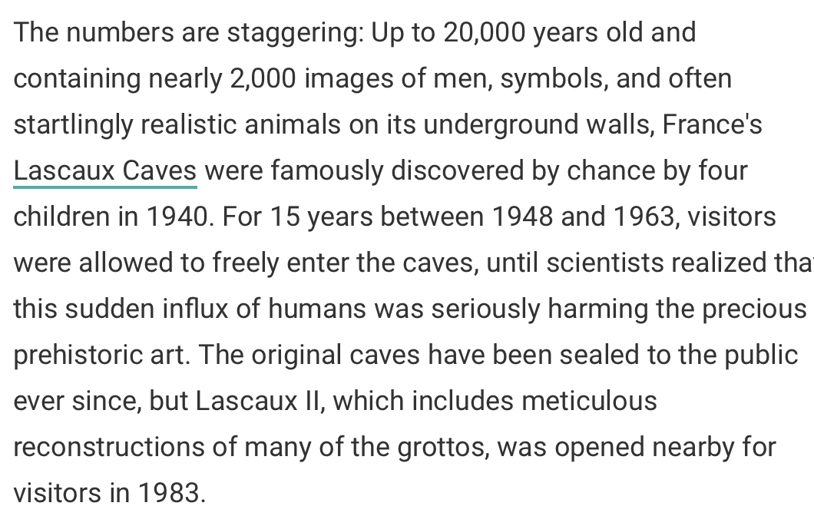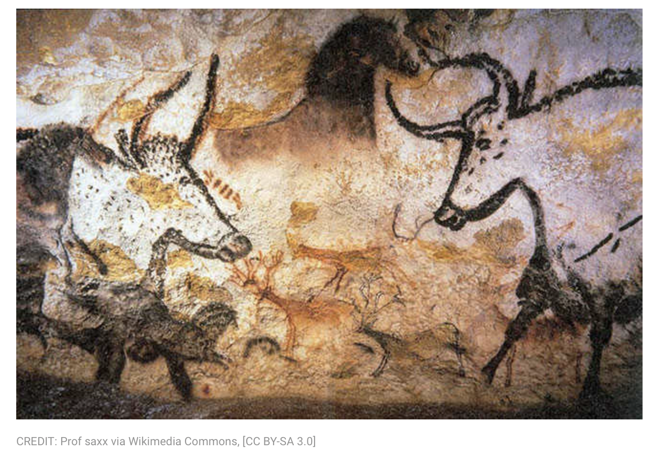

Skara Brae
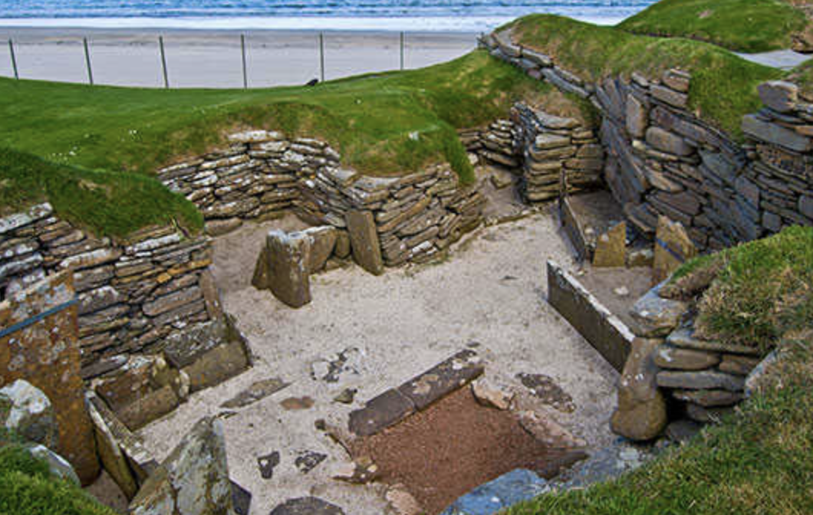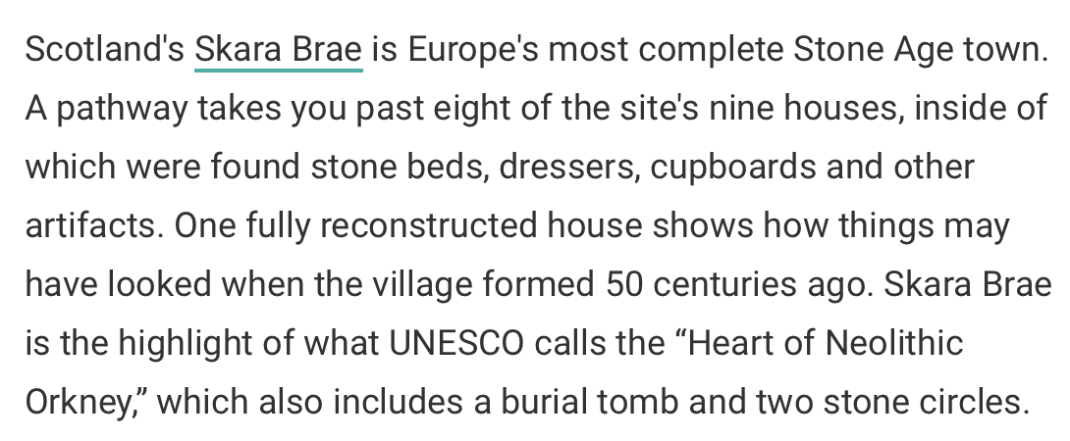

Coa Valley
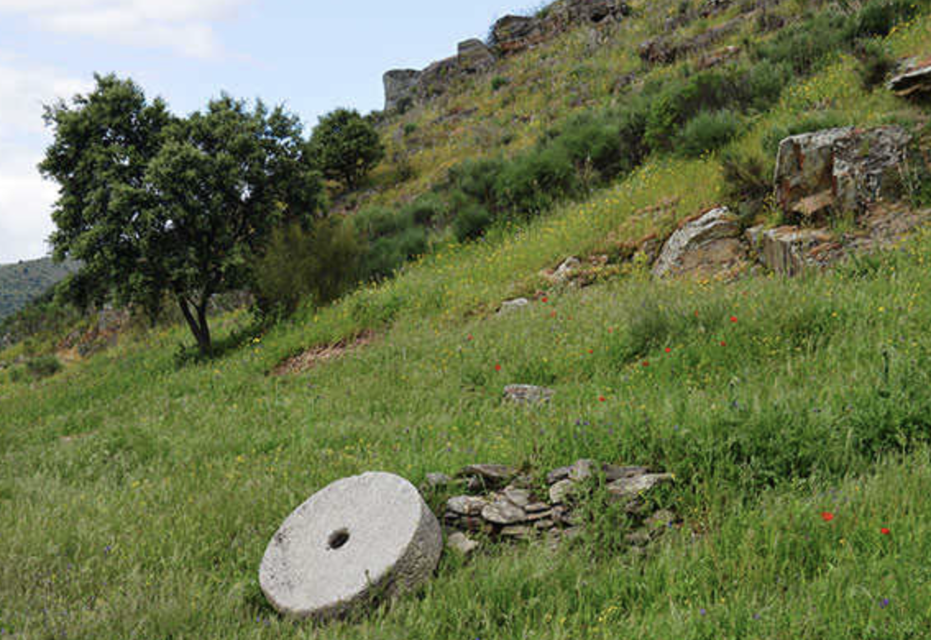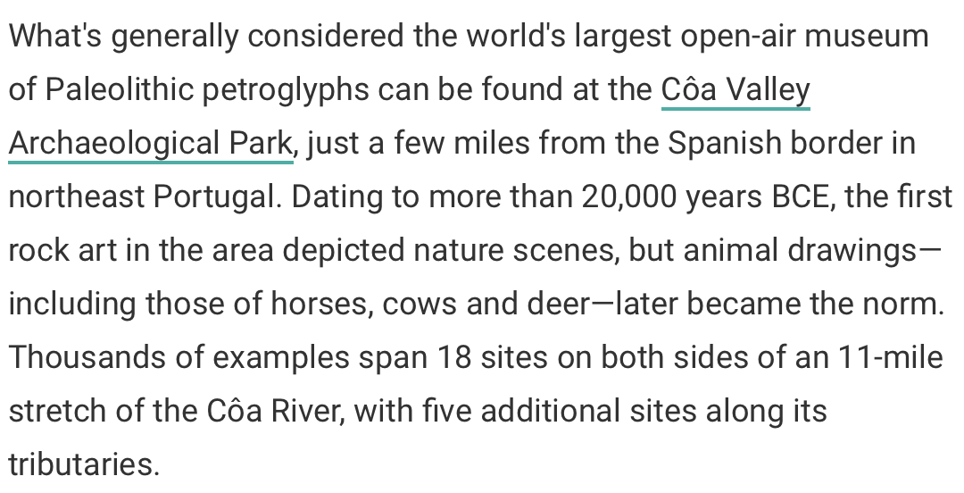

Altamira Cave
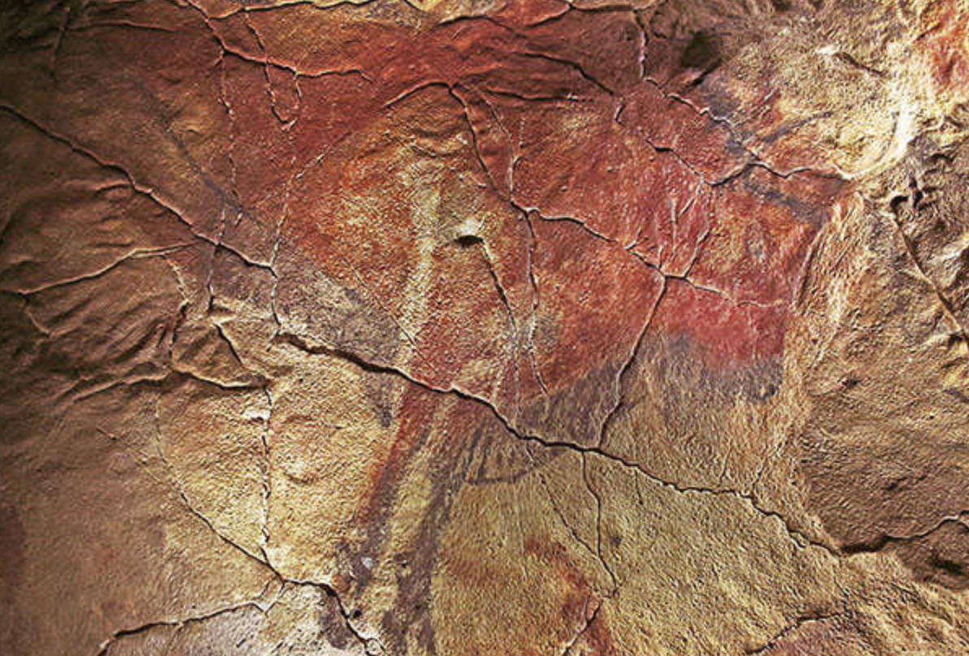
While some of its lesser-known paintings date back an astounding 35,000 years, Altamira is best known for its array of beautiful animal art dating to (a still-really-old) 15,000 years ago or so. Tourist hordes and their rampant carbon dioxide began to damage the priceless images, and the cave was restricted to limited guests after 1977, then completely closed to the public in 2002. As at Lascaux, visitors to this Spanish site now experience the art via a replica cave and museum nearby.

Sammallahdenmki
Practically new compared to other sites, Finland's Sammallahdenmäki dates back about 3,000 years—and though made of stone, is actually from the Scandinavian Bronze Age. The site's 33 cairns (or rough stone mounds) are spread over about 90 acres, and were used in burial rites as part of a farming-based sun-worship religion that had spread to Finland's coastal regions from Scandinavia.

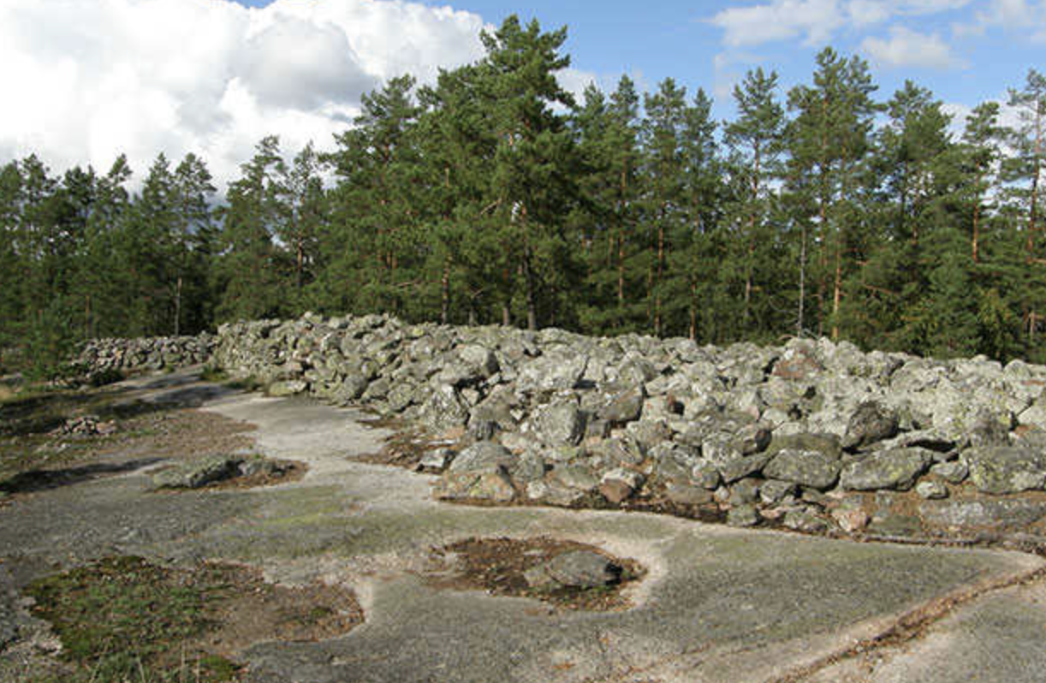

Karnave
Lithuania's Kernavė represents a rare phenomenon indeed—a prehistoric site dating back 10,000 years that's remained in constant use, albeit sometimes sparingly, until modern times, for a while even serving as the medieval capital of the Grand Duchy of Lithuania. A terrific museum displays artefacts found at the site and gives them historical (or prehistorical) context, while the paths through and over the complex's five riverside hill forts create a lovely hike through the ages

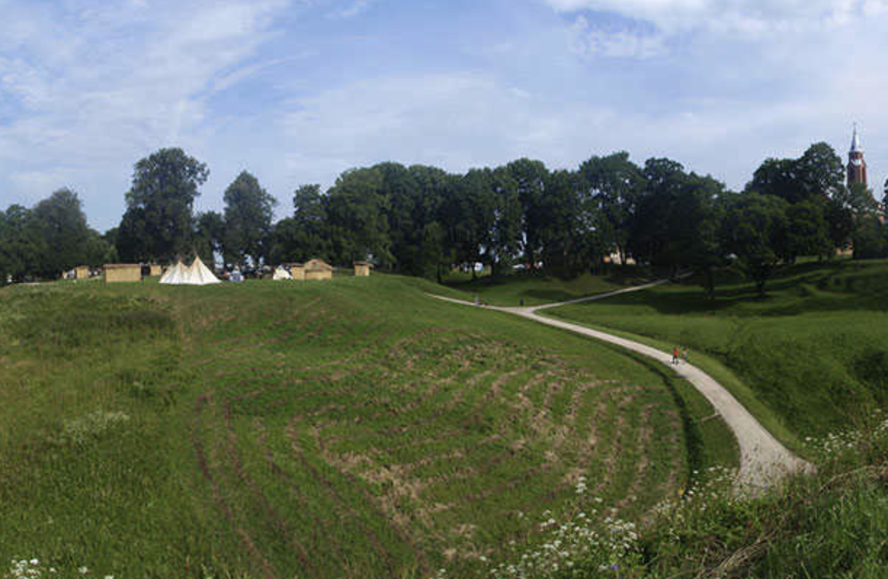

Alta Rock Art
Some of the northernmost prehistoric remains on the planet are the petroglyphs at Alta Fjord at the top of Norway, which date back some seven millennia and reflect the combined hunting and fishing culture of the peoples who created them. Spread over 45 open-air sites in five areas at the fjord's head, thousands of carvings and paintings give an invaluable insight into the mindset and spirituality of the local hunters and gatherers of prehistory.

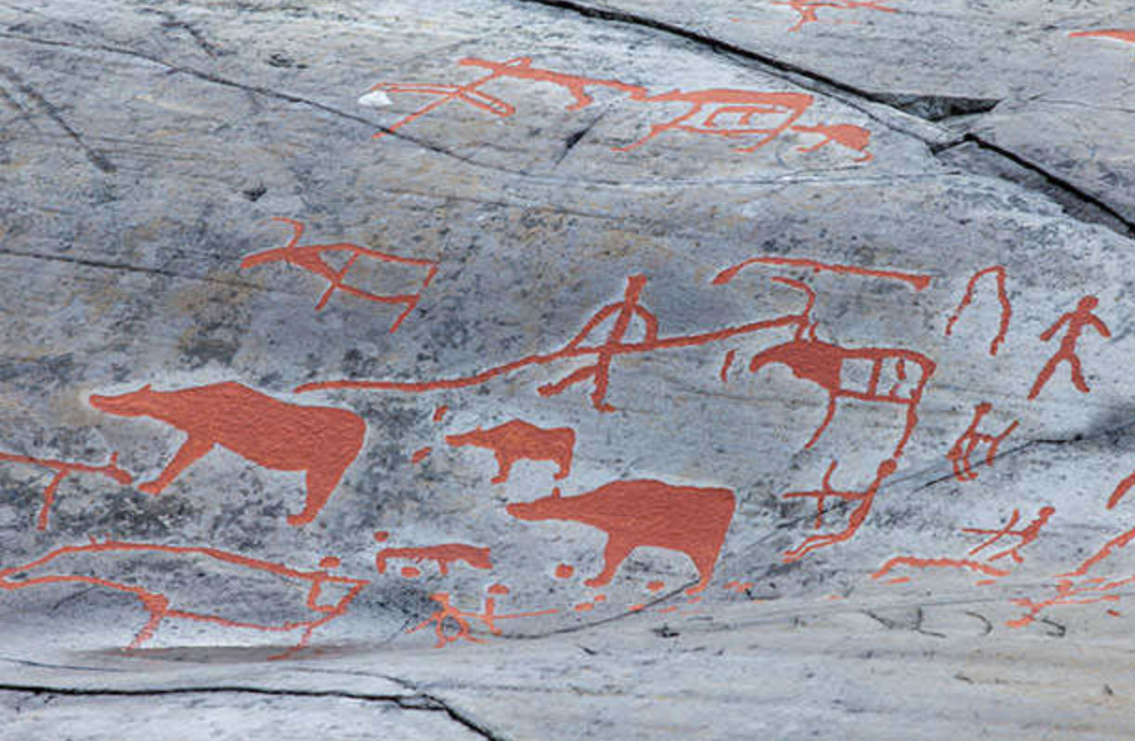

Stonehenge
Stonehenge draws approximately 1.3 million visitors every year, making it one of England's most popular attractions. Scholarship is constantly evolving about Stonehenge's origins and usages, but archaeologists now believe that work on the complex—a 108-foot-wide ring of 13-foot-high standing stones, set within huge earthworks—began more than 5,000 years ago, with revisions made throughout its use (which lasted into the Iron Age in the first millennium BCE).

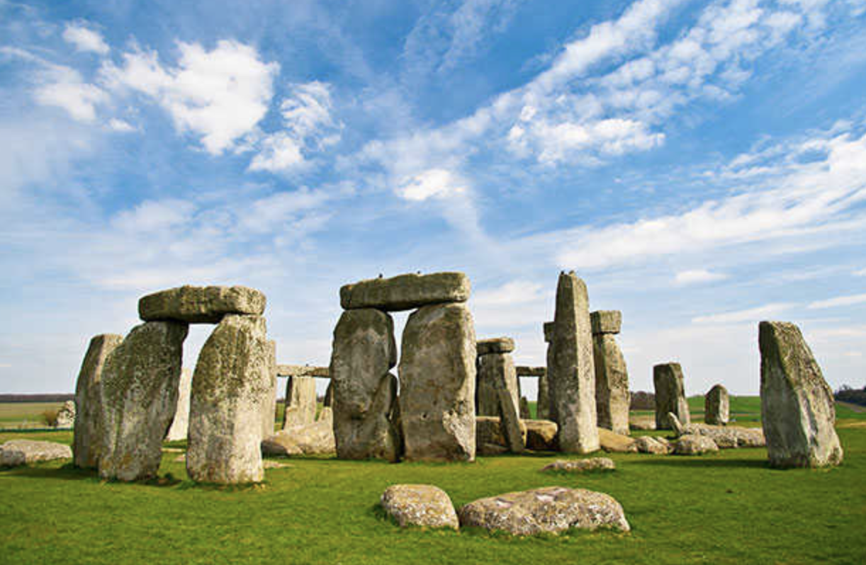

Bru Na Boinne
One of the world's most important concentrations of prehistoric structures can be found at Ireland's Brú na Bóinne, a collection of more than 90 funerary monuments dating back well over five millennia. Two of the complex's three main sites, the passage tomb mounds Newgrange and Knowth, are reached by tours from the Brú na Bóinne Visitor Centre (a third, Dowth, is off limits to the public). The mounds likely served not only as burial chambers, but also as important astrological, spiritual, and ceremonial centers for those who built them

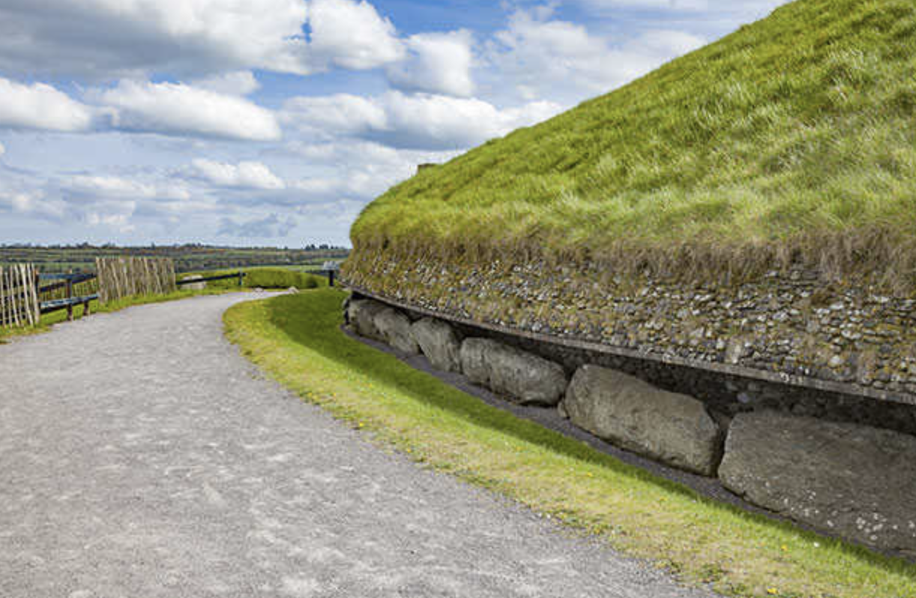

Valcamonica
One of the planet's greatest collections of prehistoric stone carvings is located in the Val Camonica valley in the Central Alps. More than 140,000 ancient figures and symbols have been found so far in the area, which covers a few hundred square miles on Italy's Lombardy plain. Depicting themes of hunting, agriculture, navigation, war, and magic, the petroglyphs date back some 8,000 years.


