Date:
L.O. To locate China on a world map
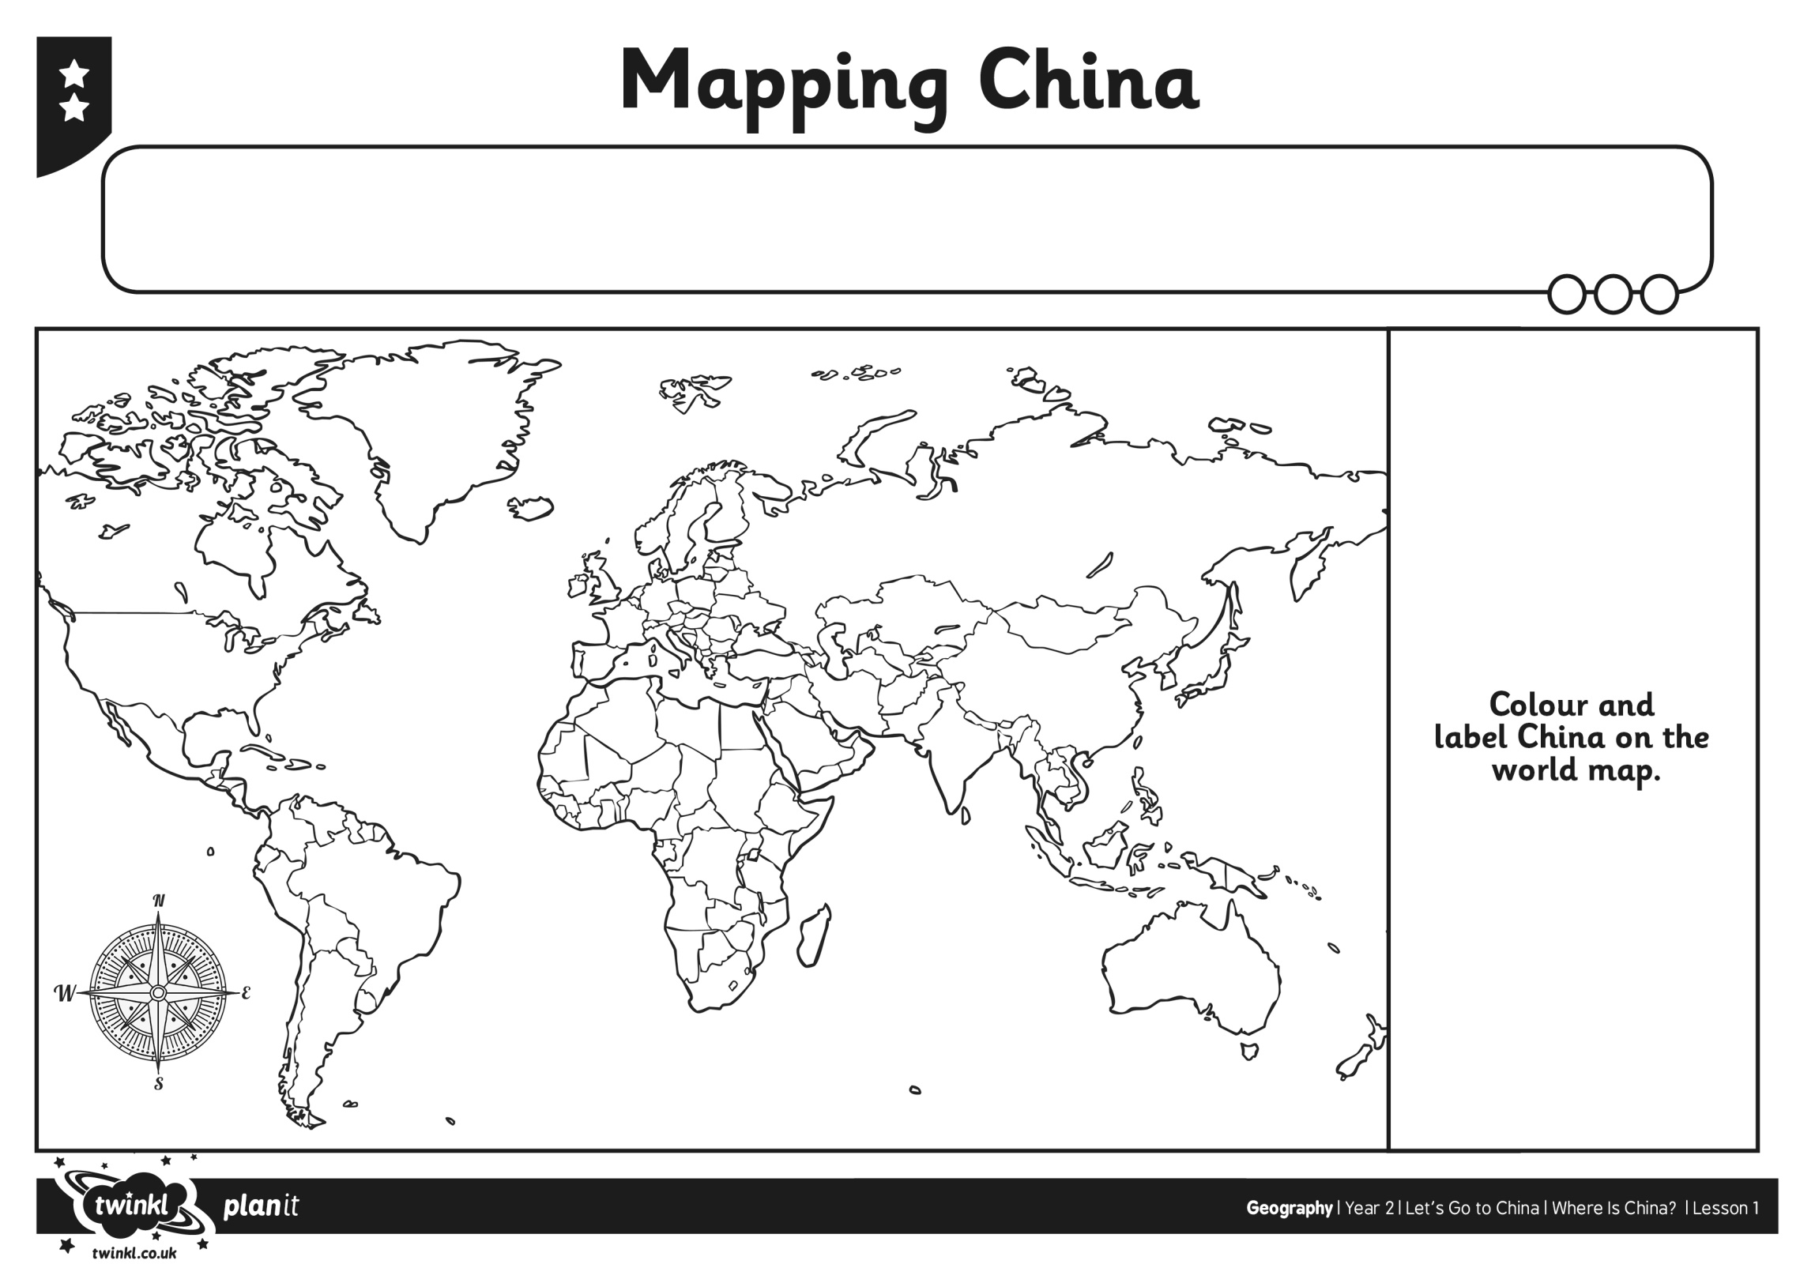

Colour in and place Paddington in China on the world map

