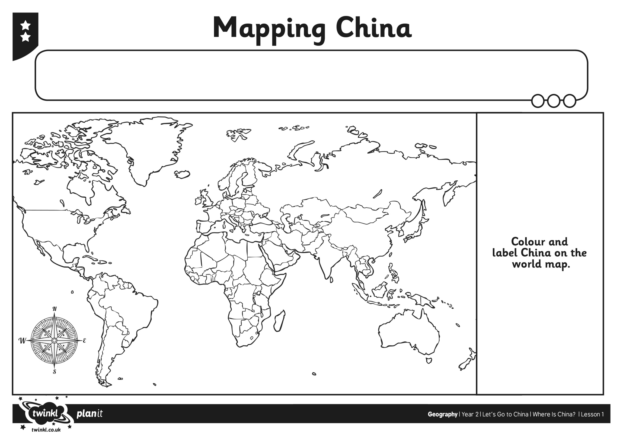
Place Paddington in China on the world map

Can you label?
- The Capital city
- An ocean nearby

Date:
L.O. To locate China on a world map

