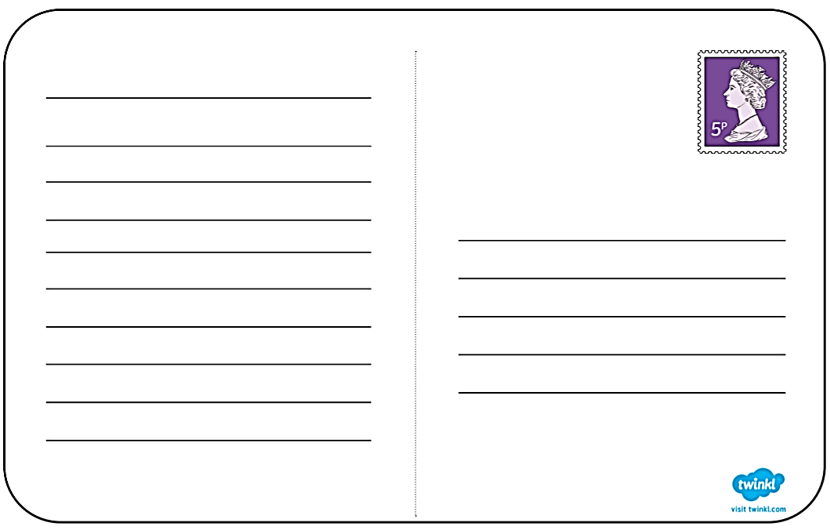
Dear _____________,

Today I have been to ________________________.

On my journey I
________________________________________________________________________.
Here I am!
Dear _______________________________

