Maths | English | Reading | Topic/Science
Weekly Focus:  Year 1:  Year 2: | Weekly Focus: | Text/s:  https://www.sciencekids.co.nz/sciencefacts/earth/antarctica.html | Topic Unit: Paddington in Peru  Science Unit:
Monday:  Year 1  https://vimeo.com/480768128  https://resources.whiterosemaths.com/wp-content/uploads/2019/10/Y1-Autumn-Block-4-WO1-Count-forwards-and-backwards-and-write-numbers-to-20-in-numerals-and-words-2019.pdf  Year 2- End of block assessment | Monday:  https://classroom.thenational.academy/lessons/to-listen-to-a-story-c5h32r | Monday: Lesson 1  https://www.sciencekids.co.nz/sciencefacts/earth/antarctica.html  - Where abouts in the world will you find Antartica?  - What is the land covered with?  - Can you remember the name of the ocaean that surrounds it?  - What is the other name for Antartica?  - What is special about Mount Erebus?  - What is a glacier?  - What happens when chunks of ice break off? | Monday:  Animals and Humans  https://classroom.thenational.academy/lessons/which-animal-families-are-invertebrates-ctgk4r
Tuesday:  Year 1:  https://vimeo.com/480769444  https://resources.whiterosemaths.com/wp-content/uploads/2019/10/Y1-Autumn-Block-4-WO2-Numbers-from-11-to-20-2019.pdf  Year 2:  https://vimeo.com/470140979  file:///T:/AYear%201%20and%202/2021-2022/Y1-Summer-Block-5-D2-Recognising-notes-2020.pdf | Tuesday:  https://classroom.thenational.academy/lessons/to-tell-a-story-from-memory-71gkgr | Tuesday:  Lesson 2-  - What is the weather like in Antartica?  - What kind of clothes would you need to wear?  - Describe what it would be like in a blizzard.  - Which 3 animals might you see ?  - How do these animals keep warm? | Tuesday: Topic  After visiting the South Pole Paddington needs warming up so he’s has travelled to a country in Europe. It has warm sunny weather has a long coastline along the Mediteran.  It borders with France, Switzerland, Austria and Slovenia. Does anybody know the country?  Paddington is on holiday in Italy  What do other things do they now know about Italy?  watch this short video  Italy video  Discuss what Paddington could do on his holiday, where might he visit and what would he eat, what clothes should he wear  When you go on holiday people have a look in holiday brochures so they know the where to visit and what to do  Children to draw and label places they remember in Italy such as tower of pisa , then food to eat , color in the flag.
Wednesday:  Year 1:  https://vimeo.com/480324356  https://resources.whiterosemaths.com/wp-content/uploads/2019/10/Y1-Autumn-Block-4-WO3-Tens-and-ones-2019.pdf  Year 2:  https://vimeo.com/471306740  https://resources.whiterosemaths.com/wp-content/uploads/2019/09/Y2-Autumn-Block-3-WO1-Count-money-pence-2019.pdf | Wednesday:  https://classroom.thenational.academy/lessons/to-explore-the-middle-of-a-story-6wukgd | Wednesday:  Handwriting sheet on Class Page | Wednesday: PE  Please complete a Joe Wicks style work out or use Cosmic Kids yoga videos on youtube. As an alternative you could go for a run or a bike rider.
Thursday:  Year 1:  https://vimeo.com/480325207  https://resources.whiterosemaths.com/wp-content/uploads/2019/10/Y1-Autumn-Block-4-WO3-Tens-and-ones-2019.pdf  Year 2:  https://vimeo.com/471307411  https://resources.whiterosemaths.com/wp-content/uploads/2019/09/Y2-Autumn-Block-3-WO2-Count-money-pounds-2019.pdf | Thursday:  https://classroom.thenational.academy/lessons/to-vary-sentence-length-for-effect-c4rk6e | Thursday:  Lesson 3-  - What is different about Antartica to the other continents?  - Who lives there?  - Can you remember the name of the explorer who first reached the South Pole.  - Why do tourists visit Antartica?  - Why can’t people mine or drill for coal and oil?  - What would you do if you went to visit Antartica? | Thursday:  Art  Create your own remembrance day poppy.  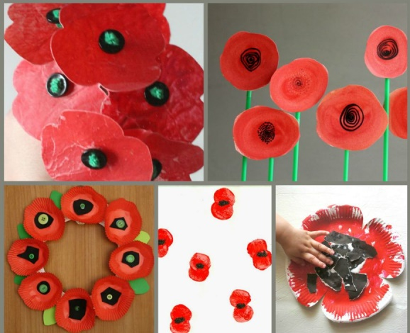
Friday:  Year 1:  https://vimeo.com/480325729  https://resources.whiterosemaths.com/wp-content/uploads/2019/10/Y1-Autumn-Block-4-WO4-Count-one-more-and-one-less-2019.pdf  Year 2:  https://vimeo.com/471307831  https://resources.whiterosemaths.com/wp-content/uploads/2019/09/Y2-Autumn-Block-3-WO3-Count-money-notes-and-coins-2019-1.pdf | Friday:  https://classroom.thenational.academy/lessons/to-make-predictions-ccwk0r | Friday:  Handwriting sheet on Class Page | Friday: Forest School  Please go for a walk to a wild area and look for signs of Autumn. Imagine you are a hedgehog and find a nice place to make a home while hibernation for the winter.  Now make a hedgehog themed piece of art or craft. You could use clay to make a model or leaves to make a picture.  Have fun!

