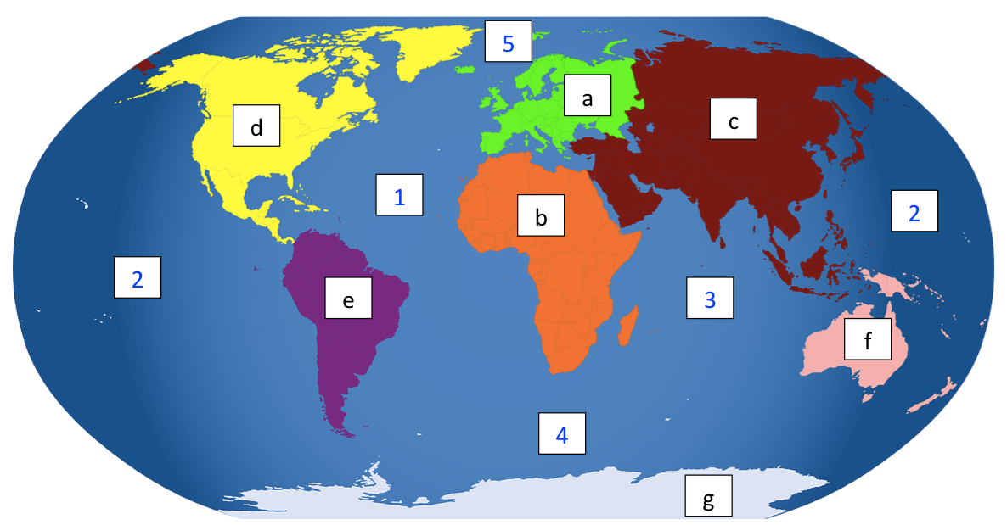
LO- To label the continents and oceans
Indian Ocean
Pacific Ocean
Southern Ocean
Atlantic Ocean
Arctic Ocean
Africa
Europe
Asia
North America
South America
Australia
Antarctica

Continents:
E

a) _____________________________ Oceans:
A
A
I
b) _____________________________ 1) _____________________________
P
A
c) _____________________________ 2) _____________________________
N A
d) _____________________________ 3) _____________________________
S A
S
e) _____________________________ 4) _____________________________
A
A
f) _____________________________ 5) _____________________________
A

g) _____________________________

