Maths | English | Reading | Topic/Science
Weekly Focus:  Year 1: Measuring  Year 2: statistics | Weekly Focus: | Text/s:  The Great Fire of London Book: (See PowerPoint)  Read Contents page | Topic Unit:  Science Unit: Animals
Monday:  Year 1  Practical activity  Spr1.8.4 - Measure length activity on Vimeo  Year 2- Practical  https://vimeo.com/504480875 | Monday:  https://classroom.thenational.academy/lessons/to-listen-to-instructions-and-answer-questions-6mu64c | Monday: Lesson 1  Read Contents page  Is the book a fiction book or non-fiction book? How do you know?  What is the difference  What is a contents page?  What is it useful for?  Where would you find information about Thomas Farriner’s Bakery? | Monday:  Begin by introducing the theme of the session, nocturnal animals, and explore what the students already know about the topic by working through the Nocturnal Animals PowerPoint presentation. See slide notes on the PowerPoint presentation for further guidance and information.  Name the sound activity – https://www.stem.org.uk/elibrary/resource/30499  Make sure each student has the hearing worksheet. Play each sound making sure you announce the number as you play it. Students then write down a number next to which animal they think the sound is.  Summarise the lesson by asking what the students remember about nocturnal animals, and to name some examples from the lesson.
Tuesday:  Year 1:  Spr1.8.5 - Measure length on Vimeo  Y1-Spring-Block-3-WO2-Measure-length-1-2019.pdf (whiterosemaths.com)  Year 2:  https://vimeo.com/504483835  https://assets.whiterosemaths.com/fixed/res/2019/12/Y2-Spring-Block-2-WO4-Draw-pictograms-2-5-and-10-2019.pdf | Tuesday: https://classroom.thenational.academy/lessons/to-tell-a-set-of-instructions-from-memory-c5hkar | Tuesday:  Read Changes to firefighting (See PowerPoint)  Discuss terms ‘basic’ and ‘techniques.’  Why do you think new and improved techniques were put into place after the great fire?  Why were horse drawn fire engines better than hand pulled fire engines?  Why was it hard to get hold of the firefighting equipment before the great fire? | Tuesday: Topic  Today the children will be reflecting on and evaluating all that they have learnt about the Great Fire of London.  Firstly, list as many key facts as you can about the Great Fire. Then, look at and read the following ‘Sticky Knowledge’ from the Topic Knowledge Organiser on the class page:  At that time, there was also a terrible disease called the plague. This was a disease that very few people survived. In fact, in the two years before the fire, around 68 000 people had died from it.  Now act out the events and what we have discovered about the Great Fire of London.  Channel 1: Children to act out putting out the embers in the bakery and going to bed  Channel 2: Children acting waking up to a fire in the bakery and climbing out onto the roof to escape  Channel 3: Children acting out using water pumps and leather buckets of water to attempt to put the fire out  Channel 4: Children acting out pulling down houses with fire hooks and using gun powder to blow up houses.  Channel 5: Children acting out gathering valuable items and fleeing London  Adult to press the different channels on the pretend remote control to give children the opportunity to act out the different events.  Reflecting on what the children have learnt, the children will complete a write up detailing what they have found out and any questions they would like to research further.
Wednesday:  Year 1:  Practical activity  Spr1.9.1 - Introducing the ruler on Vimeo  Year 2:  https://vimeo.com/504484570  https://assets.whiterosemaths.com/fixed/res/2019/12/Y2-Spring-Block-2-WO5-Interpret-pictograms-2-5-and-10-2019.pdf | Wednesday:  https://classroom.thenational.academy/lessons/to-use-imperative-verbs-6tj32d | Wednesday:  The Great Fire of London: Places (See PowerPoint)  Discuss terms ‘architect’ and ‘extended’  What does the term Guildhall refer to?  How long did the new Saint Paul’s cathedral take to build?  Sequence the changes that happened to Guildhall over the years:  A new entrance was added.  Guildhall was damaged during the great fire.  An art gallery was installed.  New roofs were built. | Wednesday: PE  You can choose to take part in a Joe Wicks workout or Cosmic kids yoga on youtube. Alternatively you may choose to go for a bike ride or a jog outdoors.
Thursday:  Year 1:  Spr1.9.2 - Measure length on Vimeo  Y1-Spring-Block-3-WO3-Measure-length-2-2019.pdf (whiterosemaths.com)  Year 2:  https://vimeo.com/504485413  https://assets.whiterosemaths.com/fixed/res/2019/12/Y2-Spring-Block-2-WO6-Block-diagrams-2019.pdf | Thursday:  https://classroom.thenational.academy/lessons/to-use-the-subordinating-conjunctions-when-and-if-cnh6ar | Thursday:  Handwriting sheet on Class Page | Thursday:  Art  Create a 3D scene of Pudding Lane on fire.  Cut out roof top shapes and fold your card into a zig zag to create a 3D effect. Stick on flames to create a burning Puddling Lane scene. Shine a torch behind to create a special effect.  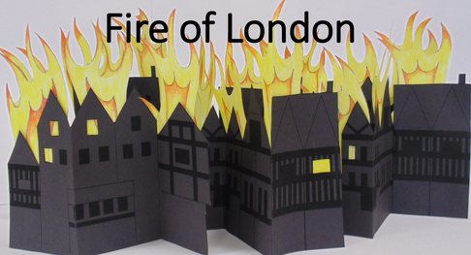
Friday  Year 1  Spr1.9.3 - Adding lengths on Vimeo  Y1-Spring-Block-3-WO-Adding-lengths-2020.pdf (whiterosemaths.com)  Year 2: End of unit quiz  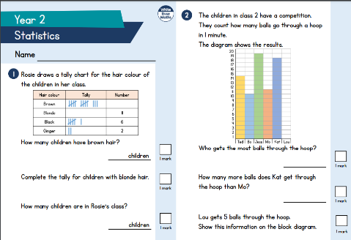 | Friday:  https://classroom.thenational.academy/lessons/to-summarise-key-points-69k34d | Friday:  Read for pleasure | Friday: Forest School  Go for a woodland walk and choose from the activities below:  Forest school tig  Hide and seek  Meet a tree game  Then have a go at making a free standing structure using natural materials. This could be a tower using sticks.  Have fun!

