LO – To label a picture of a plague doctor
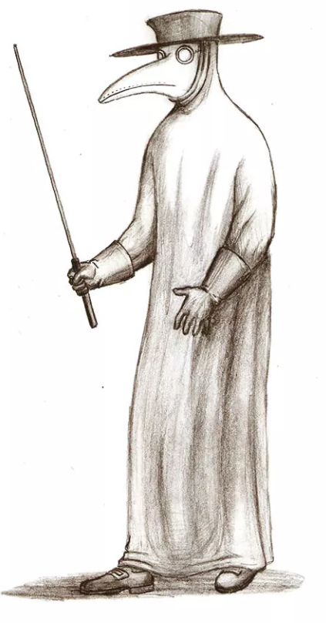

wooden stick | full length gown
beak with herbs | glass eye
leather gloves | leather hat

