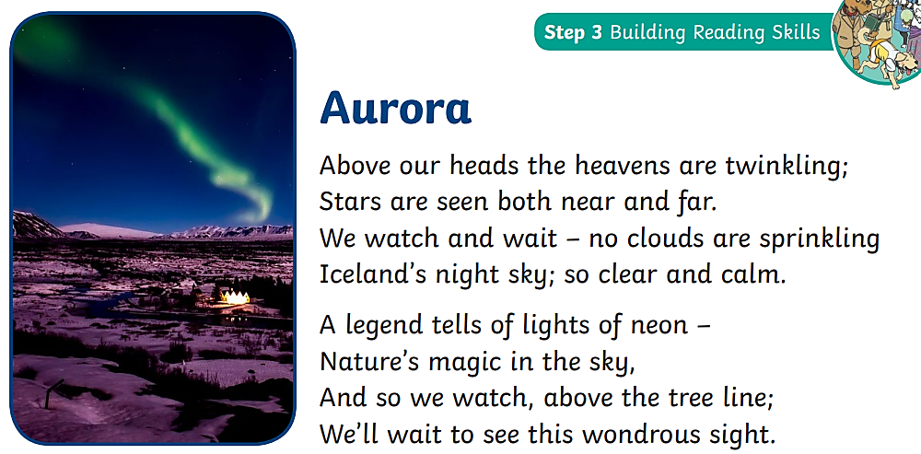

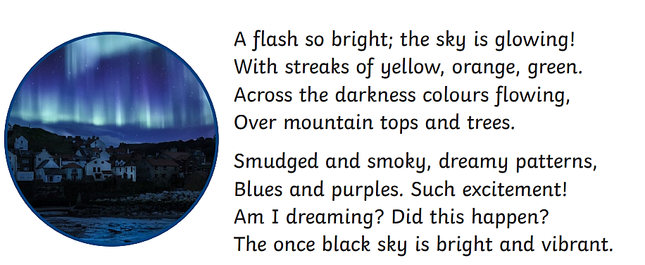

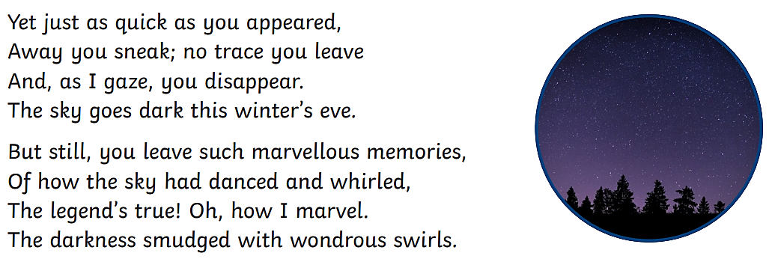

Questions

Infer
- What type of text is this?
- Which of these statements are true? Choose two.
- The poet is looking at the sky
- The poet wants to see the clouds
- The poet does not like the stars
- The poet is waiting for something to happen.

Retrieve
- What country is this poem set in?

- Which of these colours could the poet see in the sky?
- Red
- Orange
- Yellow
- Pink
- Blue
- Green

- Complete this sentence using adjectives from the poem.
The sky used to be _________ but now it is __________ and
_____________.
Sequence
- Put these events in the order that they happened in the poem.
- The stars above the poet’s head are twinkling in the sky
- The lights disappear
- The poet wonders whether they are dreaming or not
- Smudged and smoky patterns can be seen in the sky
- The poet speaks about their memories of the light

