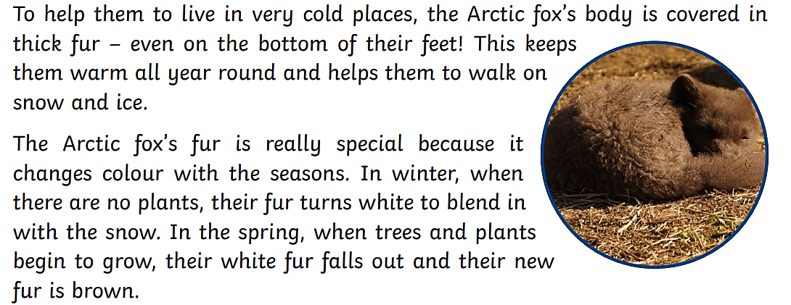
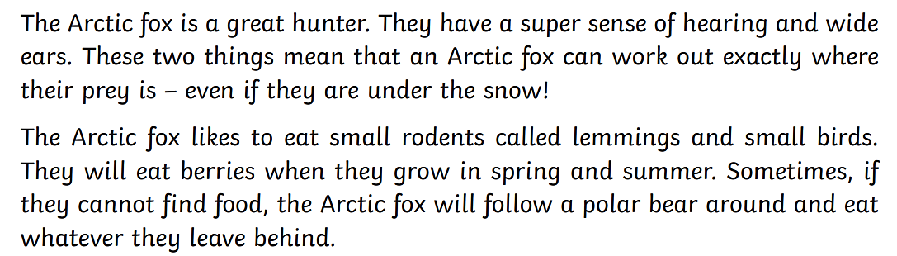
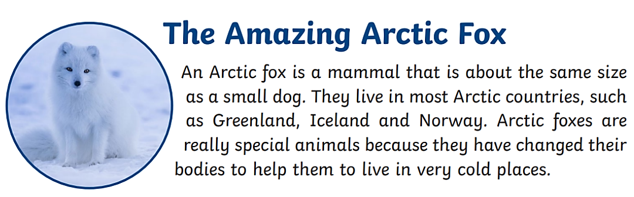

Questions

Retrieve
- Write one word to complete this sentence:
The Arctic fox is about the same size as a small ____________.

- Which of these countries can the Arctic Fox be found in? Choose 3.
- England
- Norway
- Spain
- Iceland
- Scotland
- Greenland

Explain
- Why does the Arctic Fox sometimes follow a Polar Bear around?

Sequence
- Number the facts below in the order that they appear in the text.
- There body is covered in thick fur.
- The Arctic Fox is a great hunter.
- An Arctic Fox is a mammal.
- They live in the most arctic countries.
- Sometimes they follow around a polar bear.

