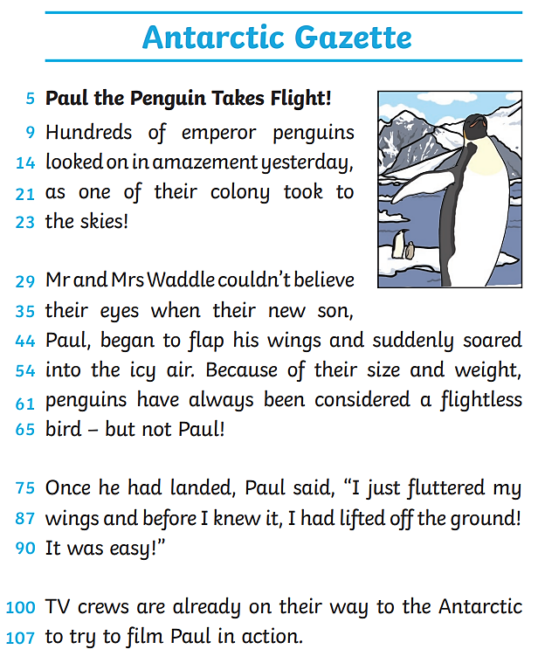

Questions

Infer
- What type of text is this?

Retrieval
- What type of penguin is Paul?

Vocabulary
- What verb does the author use instead of ‘flew’?

Explain
- Why do TV crews want to film Paul?

Infer
- How do you think Mr and Mrs Waddle feel about their son?

